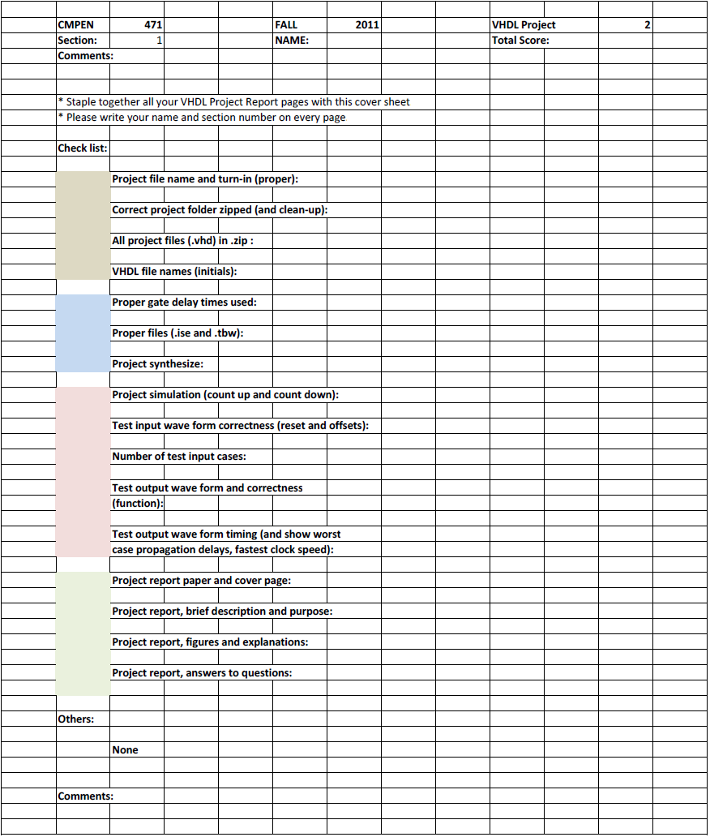
Erik Arfvidson
5

Erik Arfvidson
10/11/2012
Lab5

Project Report5

Purpose and Description

Design, implement, simulate, and debug Simple Microcontroller with 4 instructions and 3 addressing modes. Use ROM of Project 3 and RAM of Project 4. In this project our objective was to develop a Microprocessor capable of handling 6 bit Instructions. This project will provide crucial concepts and understanding of the development of microcontrollers.

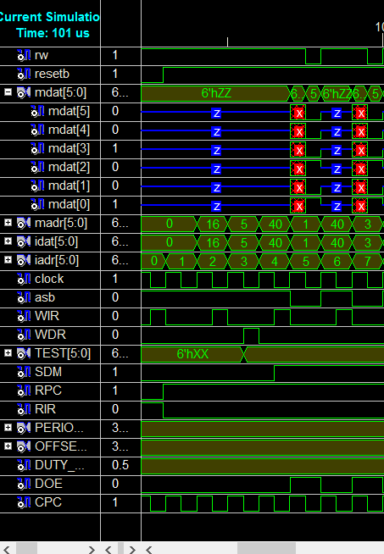
Simulations 1

The first command is a noop followed by Load 5 to the register and then Storing 5 into the memory address one and three

Simulation 2

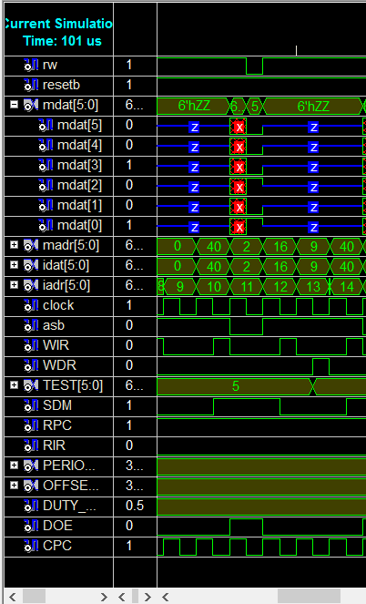

The first instruction in this segment is a noop followed by a store 5 to memory address 2. The last instruction is Load Immediate number nine to the register.

Simulation3

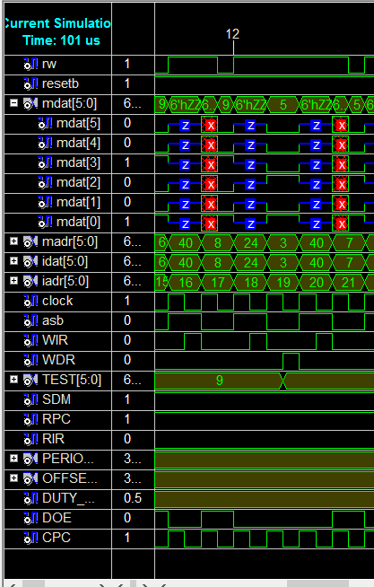
This Simulation is pretty Straight forward. The first instruction is Store 9 to memory Address 6 and memory address 8. Then we load memory address 3 to the register file. The image also demonstrates the short error that occurs due to the ID not been a 100 percent accurate on the gate delays.

Simulation4
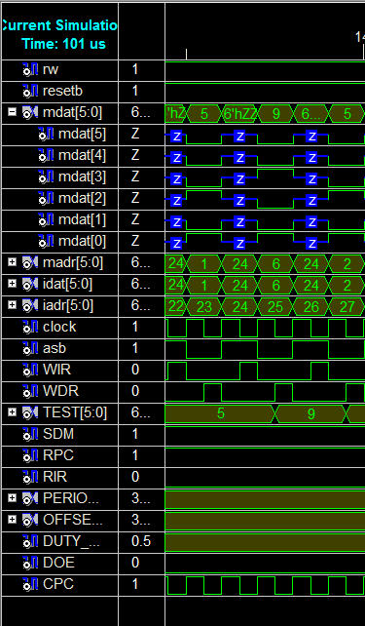
In this simulation we store the value of memory addres three and store it to 7. Then We load memory address 1 to the register file. Then we load Memory Address 6, followed by another load of 2.

Simulation5
This is my last simulation of all the instructions given in the assignment. We first load 7 then 3 and then 8 and we finalize with a noop. I didn’t include the noop part because I found it to be unnecessary.

Testbench1

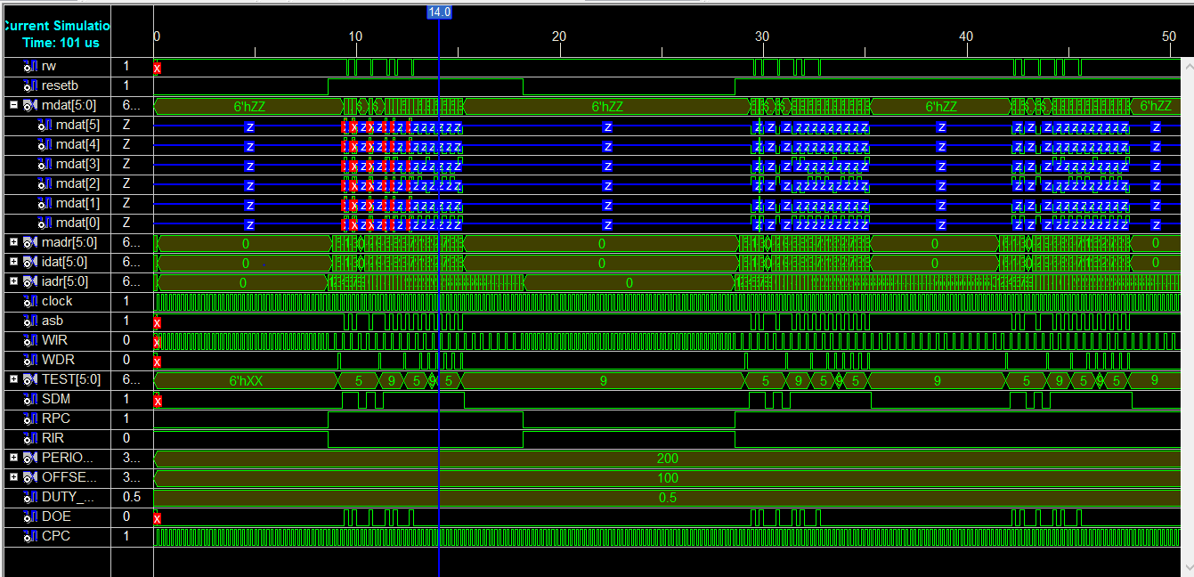
This is an image of the simulation of test bench1 that Runs program once and then reset and run it again.

TestBench2
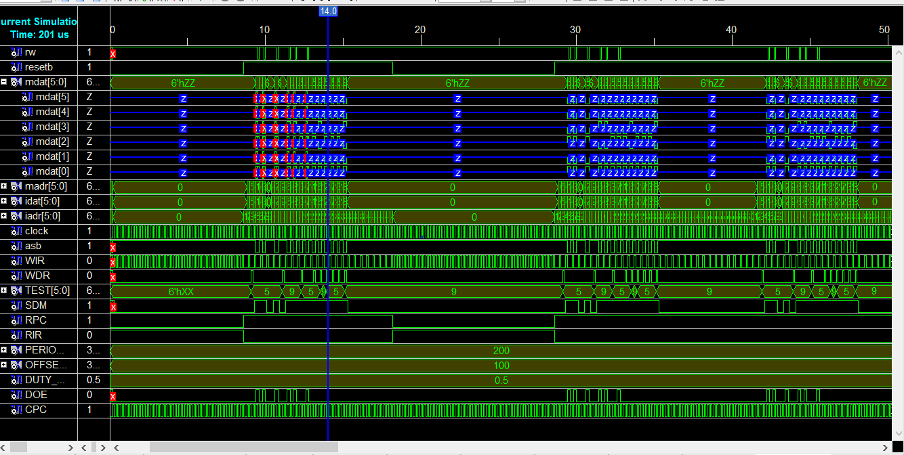

This is a simulation that includes the instructions that I added to the rom file. I saved and loaded in different registers than the ones provided in the example.

The maximum that achieved on my simulation was around 700Mhz before it Started to fail.

